Resource Pack for the Economics Curriculum (S4-S6)

Personal, Social and Humanities Education Section
Curriculum Development Institute
Education Bureau
2021
Income Inequality and Poverty
Preface
Income inequality is one of the topics covered in the Economics Curriculum, and poverty is a concern for governments all over the world. The Education Bureau publishes this resource pack to support the learning and teaching of concepts related to income inqualtiy in the Economics (S4-6). The Pack introduces concepts and measurement methods related to income inequality and poverty, and analyses the possible causes of these two issues, as well as the government’s measures. This will be followed by some suggested questions for further enquiries related to this topic. The final section of this Pack introduces references books on income inequality.

It is our honour to have Dr. Lee Shu Kam, Director of Business, Economic and Public Policy Research Centre, Hong Kong Shue Yan University to develop this resource pack for the Education Bureau.

The primary users of this resource pack are teachers and students. Teachers may provide appropriate supplementary notes/explanations or arrange students’ pre-lesson/extended learning activities to meet the learning and teaching needs. Teachers are welcome to share suggestions for improvement, and provide updated information to enrich the content for all teachers’ reference. If you have any comments or suggestions about this Pack, please send them to:
Chief Curriculum Development Officer (Personal, Social and Humanities Education) 1
Curriculum Development Institute
Education Bureau
Room 1319, 13/F., Wu Chung House
213 Queen’s Road East, Wanchai, Hong Kong
E-mail: info_pshe@edb.gov.hk
Contents
Contents | Page
Income inequality and Poverty | 1
Part I: Definition and measurement
1.1 Income inequality in Hong Kong
1.1.1 Official measurement in Hong Kong | 2-4
1.1.2 Interpretation issues about Gini Coefficient | 4
1.1.3 Housing factor | 5-7
1.2 Poverty in Hong Kong
1.2.1 Definitions of poverty | 7-8
1.2.2 Official measurement in Hong Kong | 8-9
1.2.3 Interpretation issues about measurement | 9-10
1.2.4 Poverty situation in Hong Kong | 10-12
1.2.5 Poverty rate and poor population by selected socio-economic groups | 12-15
Part II: Sources of income inequality and poverty
a. Different level of human capital (innate ability, education and training) | 16
b. Hiring and promotion discriminations in age, gender, race, religion, and the effect on hiring and wage rate | 16-17
c. Occupation and region | 17-19
d. Capital ownership and property income | 19-20
e. Tastes and risk preferences | 20
f. Market structures of both product market and labour market | 20
g. Technological advancement | 20
h. Change of economic condition (e.g. pandemic of COVID-19) | 21-22
i. Globalization | 22
j. Luck or misfortune | 22
Part III: Measures of mitigating income inequality and poverty
3.1 Measures
a. Minimum wage | 23
b. Rent control | 24
c. Progressive income tax | 24
d. Negative income tax | 24-25
e. Social security programs | 25
f. In-kind transfer programs | 25
g. Subsidized services | 25
h. Social support programs | 26
i. Family-friendly policy | 26
j. Alleviation of discrimination | 26
3.2 Policy choice from the tradeoff | 26-27
3.3 Examples of policy measures in Hong Kong | 27-28
Part IV: International practices
4.1 Income Inequality | 29
4.2 Poverty | 30-31
Part V: Suggested questions for further enquiries | 32-39
Useful materials for the topic | 40
Further Reading | 41

Income inequality and Poverty
In 2013, the book “Capital in the Twenty-First Century” written by the French economist, Thomas Piketty, drew attention to the risks of severe economic inequality. Inequality can be measured as the difference in living standard across the population in a geographic region. Inequality matters for poverty, economic growth, and basic human rights. Poverty is often a crucial driver behind crime, social unrest, and thus “No poverty” forms an indispensable part of the Sustainable Development Goals established by the United Nations. The concept of poverty is related to but distinct from that of inequality. Inequality concerns about the relative distribution of societal well-being, while poverty only concentrates on the lowest part of the left tail of income distribution, i.e. the segment below the poverty line.
Due to income mobility, an individual may undergo several career and lifecycle stages with different levels of income and accumulated wealth. Economists are more interested in examining income inequality over the life cycle instead of in any given year. However, recent evidence reveals that inequality emerges for the younger cohorts over time. The measure of inequality should capture not only the distribution of income, but also the distribution of wealth and capital income. Inequality reinforces poverty and impedes the capacity to grow. More equitable distribution of income and wealth provides the poor with more opportunities to enhance their earning power and improve their standard of living. Though a certain extent of inequality is still an acceptable state of affairs, poverty is an unacceptable extreme of inequality, which deteriorates much more severe during the recession, and necessitates responsible policy action from the government. Evidence confirms that redistributive policies are strategic for poverty reduction. Policy interventions include ongoing lifelong investment in new skills and access to social protection during work transitions in changing work environments. The accompanying distribution objectives, for instance, nurturing human capital, create indispensable value on the works of poverty reduction.
Part I: Definition and Measurement
1.1 Income inequality in Hong Kong
1.1.1 Official measurement in Hong Kong
The main measure of income inequality in Hong Kong is the Gini coefficient (GC) via constructing a Lorenz Curve. The value of a Gini coefficient (GC) is bounded between zero and one. A value of “zero” indicates absolute equality in the household income distribution, with every household having an equal share of the total household income. A value of “one” represents complete disparity where one household earns all the household income while the remaining households earn nothing. The larger the GC, the greater the income inequality.
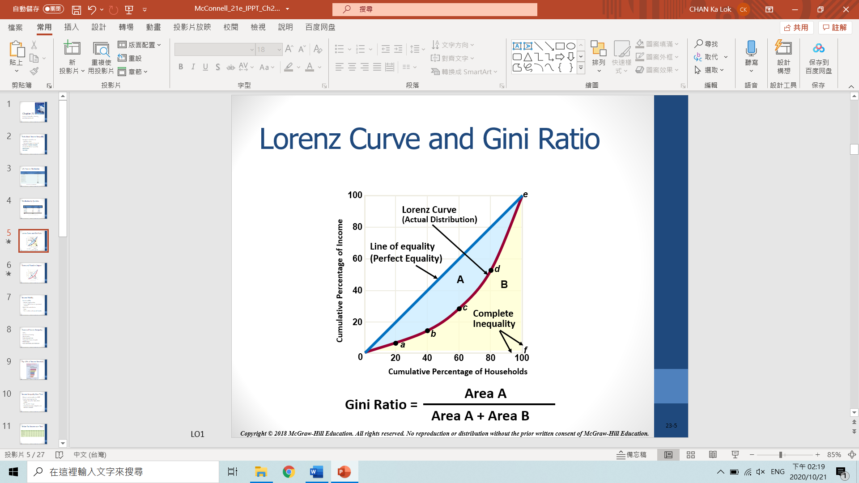  (a) | 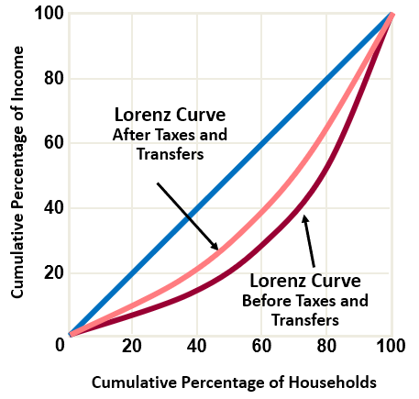  (b)
Figure 1: Lorenz Curve (a) without and (b) with the effect of redistributive measures
Calculation of the GC is based on monthly household income in this resource. In Hong Kong, three concepts of household income comprising the overall redistributive impacts and the actual economic well-being of households are used and shown in Table 1.
Income concept | Calculation formula
Original monthly household income (MHI) | = Income from main employment + Income from secondary employment + Other cash incomes (including dividends, rental incomes and other transfer incomes)
Post-tax monthly household income | = MHI – Salaries tax – Property tax – Rates – Government rent
Post-tax post-social transfer monthly household income | = Post-tax household income + Education benefits + Housing benefits + Medical benefits

Table 1: Formula for original monthly household income, post-tax household income and post-tax post-social transfer household income
Source: Census and Statistics Department, HKSAR Government
Gini Coefficients | 2006 | 2011 | 2016
GC (Original monthly household income) | 0.533 | 0.537 [+0.004] | 0.539 [+0.002]
GC (Post-tax monthly household income) | 0.521 | 0.521 [-] | 0.524 [+0.003]
GC (Post-tax post-social transfer monthly household income) | 0.475 | 0.475 [-] | 0.473 [-0.002]
Table 2: Gini Coefficients in Hong Kong
Source: Census and Statistics Department, HKSAR Government

Note that a Gini coefficient below 0.2 indicates equitable income distribution, 0.2-0.3 indicates fairly equitable, 0.4 is the international inequality threshold alert line, 0.4-0.5 indicates fairly inequitable, and above 0.5 indicates considerable disparity. Based on the original monthly household income, the Gini Coefficient was calculated as 0.539 in 2016, as shown in Table 2. The GCs of Hong Kong appear rather high.
Taking into account the effects of taxation and transfer of in-kind social benefits (including education, housing and medical), the GC (post-tax post-social transfer monthly household income) was 0.473, i.e. fairly inequitable, in 2016. It was slightly smaller than that in 2011 which could be interpreted as an improvement in the employment and income level of the grass-root workers and the rising of cash social benefits to counter the effect of accelerating aging issues on income disparity. Nevertheless, the changes in the GCs over the period 2006-2016 have been less than 0.005, which was quite stable in all the three measures.
For a closer look at the extent of income inequality in household income distribution by referring to variation of the shares of households in decile groups across time in Table 3, all households are categorized into 10 groups of equal size and ranked by household income. The 1st decile group consists of 10% of households with the lowest income, whereas the 10th decile group consists of 10% of households with the highest income.
Based on the original monthly household income, shares of households in all decile groups remained stable over the period 2006 to 2016. The biggest decline in its share of the post-tax post-social transfer monthly household income can be observed in the 10th decile group which recorded a reduction to 35.7% in 2016 from 36.2% in 2006.
Decile group | Original household income |  |  | Post-tax post-social transfer household income
Decile group | 2006 | 2011 | 2016 | 2006 | 2011 | 2016
1st (lowest) | 0.8% | 0.7% | 0.7% | 1.1% | 1.0% | 1.0%
2nd | 2.1% | 2.0% | 2.0% | 2.7% | 2.7% | 2.7%
3rd | 3.2% | 3.1% | 3.0% | 4.0% | 3.9% | 3.9%
4th | 4.3% | 4.2% | 4.1% | 5.3% | 5.1% | 5.1%
5th | 5.5% | 5.6% | 5.4% | 6.5% | 6.4% | 6.4%
6th | 7.0% | 7.0% | 7.1% | 7.8% | 7.8% | 7.9%
7th | 8.8% | 8.9% | 9.0% | 9.4% | 9.5% | 9.6%
8th | 11.3% | 11.5% | 11.6% | 11.7% | 11.8% | 11.9%
9th | 15.6% | 16.1% | 16.1% | 15.3% | 15.8% | 15.7%
10th (highest) | 41.4% | 41.0% | 41.0% | 36.2% | 36.0% | 35.7%
Table 3: Percentage distribution of original monthly household income, post-tax monthly household income and post-tax post-social transfer monthly household income by decile group, 2006, 2011 and 2016
Source: Census and Statistics Department, HKSAR Government

1.1.2 Interpretation issues about Gini Coefficient
A high-income country and a low-income country can yield the same GC, as long as their incomes are distributed in a similar pattern. For example, according to the information of OECD, though Turkey and the U.S. both had their GCs around 0.39-0.40 in 2016, Turkey’s per capita GDP was less than half of that of the U.S. (in 2010 dollar terms).
Moreover, as GC only measures household income distribution, it does not take into account the assets owned by households and thus not fully represent the living conditions of those “income-poor, asset-rich” households. Thus, GC should be interpreted with caution for assessing the extent of inequality between the rich and the poor.

1.1.3 Housing factor

Figure 2: Median household income, price and rent indexes of small living units (2007-2019)
Source: Rate and Valuation Department, HKSAR Government and Hong Kong Annual Digest of Statistics

Figure 3: Annual change of owner-occupiers and the ratio of owner-occupiers to all households (2007-2019)
Source: Hong Kong Annual Digest of Statistics
Income inequality in Hong Kong can clearly be reflected in the housing situation shown in Figure 2. Over the period 2009 to 2019, the price and rent of small units increased by 253.8% and 111.1% respectively, while the median household income only increased by 54.8%. For instance, a property valued at HK$4 million in 2009 appreciated to HK$14.1 million in 2019. As such, ownership of housing assets amplifies the wealth gap between households with housing assets and those without housing assets. In addition, from 2009 to 2019, the ratio of owner-occupiers to all households reduced from 53.06% to 49.8%, as shown in Figure 3.

Figure 4: The ratio of housing expenses to total household expenses for Hong Kong
Source: Census and Statistics Department, HKSAR Government
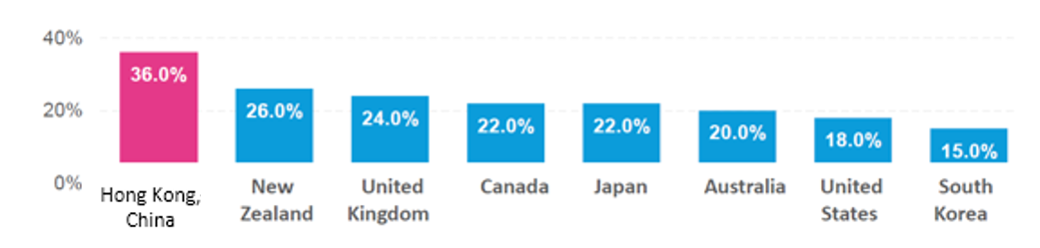
Figure 5: The ratio of housing expenses to total household expenses for Hong Kong and other developed countries
Source: OECD

In addition to the rapid rise in property prices, the growth rate of rental rates is also higher than that of the median household income, where poor households suffer the most from the higher burden of housing costs. As shown in Figures 4 and 5 above, the ratio of housing expenses to total expenses has risen from 30.6% in 2004/05 to 36.0% in 2014/15, which was more than 40% the average of the seven OECD countries. Those poor households can only afford to live in subdivided flats in Hong Kong. In 2016, a total of 92,700 subdivided flats were resided by 210,000 residents. The number of subdivided flats and residents increased by 4.3% and 5% respectively from 2015, reflecting the housing issue in Hong Kong.

1.2 Poverty in Hong Kong
1.2.1 Definitions of poverty
Based on the Commission on Poverty (CoP) of the HKSAR Government, the contestable concept of poverty can be categorized as follow:
- Absolute Poverty
Absolute poverty can be measured as below the minimum level of subsistence, i.e. insufficient earnings to afford a bundle of goods and services that is essential to the physical need of an individual or a family.
- Relative Poverty
According to British sociologist Peter Townsend (1979), people are living in relative poverty when they lack the resources to obtain the type of diets, participate in the activities and have the living conditions and amenities which are customary in the society to which they belong. The common measure of relative poverty is a proportion of the median income in a specific society.
- Hybrid approach
Budget Standards method, firstly introduced by Townsend and further modified by Bradshaw (1990), is a hybrid approach. A standard budget is a comprehensive list of budget items with their market prices to determine the expenditure amount. When the actual expenditure is lower than the standard budget, it is considered as living in poverty. This method can provide flexibility to change any items in the representative budget basket.
The limitations of various approaches are listed in Table 4.
Approach | Concept | Limitations
Absolute poverty | “minimum subsistence” | - It disregards the social needs of human beings.  - Determination of necessities remains controversial.
Relative poverty | A person has less than others, based on societal norm | - A fixed proportion of the population is always considered as poor.  - The poverty figure does not reveal the quality of life of the poor.  - Determining an acceptable minimum standard remains controversial.
Budget standards | “Minimum subsistence” plus “basic minimums for social lives” | - The choice of necessities remains controversial.  - The work of updating an expenditure budget is substantial and costly.
Table 4: Defining poverty
1.2.2 Official measurement in Hong Kong
Before 2013, the Government of Hong Kong did not officially define a poverty line. Instead, the Comprehensive Social Security Assistance (CSSA) level has practically been used as the de facto “poverty line” since 1971. The standard rates, supplements, and special grants of the CSSA scheme are computed based on an individual’s “basic needs budget” accordingly. Hence, the “absolute poverty” concept has been adopted by the HKSAR Government to define poverty.
In September 2013, the Commission of Poverty (CoP) of the HKSAR Government established the first “poverty line”. As a policy tool, its objectives are: (a) to identify the population of the poor for understanding the overall poverty situation; (b) as input for the formulation and implementation of various government policies and measures; and (c) to evaluate policy effectiveness of poverty alleviation. After several rounds of discussions, the CoP finally agreed that the poverty line should be based on the concept of “relative poverty” and set at 50% of the median monthly household income before policy intervention (i.e. tax and transfer payment). As shown in Figure 6, six poverty lines are established according to their household sizes.
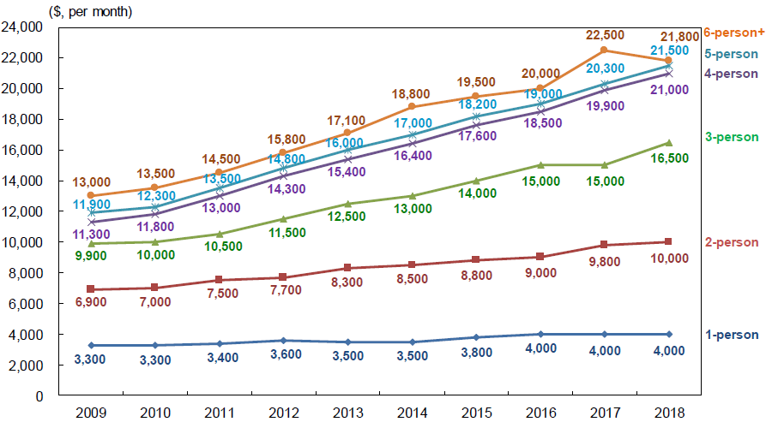
Figure 6: Poverty lines by households size, 2009-2018
Source: Census and Statistics Department, HKSAR Government
[Remarks: To compare the effects of redistributive measures on household income, “pre-intervention” poverty statistics and “post-intervention” statistics are compiled. “Pre-intervention” poverty statistics are compiled with the assumption of no prevailing government policies and measures, whereas “post-intervention” poverty statistics are compiled with monthly household income, which is supplemented by income provided by government policies and measures, including recurrent cash, non-recurrent cash benefits, and in-kind benefits (mainly public rental housing).]

Apart from the poverty line, the poverty rate is also a useful indicator for measuring the extent of poverty. According to the official definition of the Hong Kong Government, it is expressed as the ratio of the poor population to the total population living in domestic households. To update the current poverty situation, the Census and Statistics Department publishes the “Hong Kong Poverty Situation Report” every year.

1.2.3 Interpretation issues about measurement
a. The official definition of the poverty line and income threshold may not accurately measure the poverty being experienced. For example, for those living in large (and expensive) cities, though earning above the official poverty line, often struggle to meet their basic needs. One reason is that the poverty line has been established on the national average, which is definitely lower than the actual poverty line in the major cities, where the costs of living are considerably higher. Therefore, for the city people whose earnings are not far above the official poverty line (national average), despite not being declared as poor by government standard, are in fact living in poverty.

b. Also, poverty statistics are based on income, which do not include withdrawal from saving, borrowing, sale of assets, and so on. Some people still struggle to survive even when earning above the official poverty status (national average), as in point (a) above. Therefore, poverty statistics should preferably be based on actual consumption.

1.2.4 Poverty situation in Hong Kong
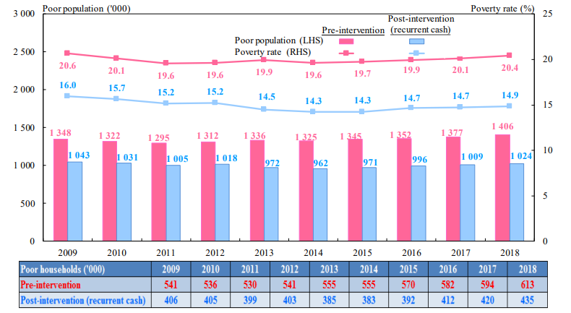
Figure 7: Poor population and poverty rate, 2009-2018
Source: Census and Statistics Department, HKSAR Government

Based on Figure 7, the pre-intervention poverty rates in Hong Kong had been rising again as from 2014. From 2017 to 2018, the number of poor households, poor population and the poverty rate increased by18,800, 29,800 (19,000, 29,000 reading from the graph) and 0.3% respectively. Similarly, after taking into account the government’s poverty alleviation efforts, the post-intervention poverty rate (after the recurrent cash policy) still slightly rose by 0.2% to 14.9%. The number of poor households and poor population rose by 15,000 and 15,500 (both 15,000 reading from the graph) respectively.
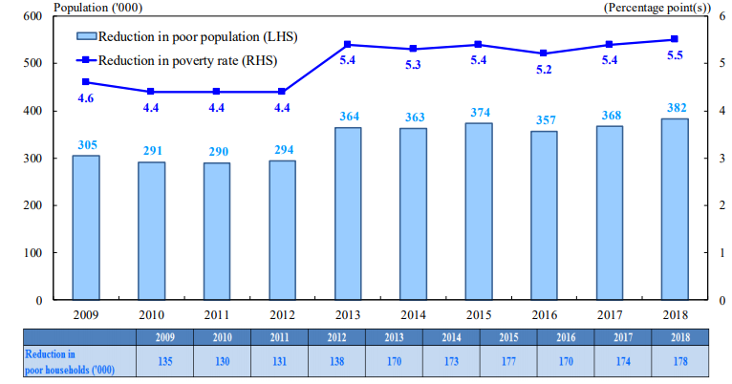
Figure 8: Effectiveness of recurrent cash policy in poverty alleviation, 2009-2018
Source: Census and Statistics Department, HKSAR Government

A comparison of the poverty numbers and rates before and after policy intervention is a useful assessment of the effectiveness of the government’s poverty relief measures. As shown in Figure 8, the government’s recurrent cash benefits lifted 178,100 households and 382,200 persons (178,000 and 382,000 reading from the graph) out of poverty in 2018. The poverty rate in 2018 was also reduced by 5.5%, which recorded the highest rate since 2009. Both policy outcomes were better than those achieved in 2017.
From the district-level comparison shown in Figure 9, in 2018, the pre-intervention districts with larger poor population were Kwun Tong (175,800), Yuen Long (129,300), Sha Tin (126,300), Kwai Tsing (111,800) and Tuen Mun (103,500); and the districts with higher poverty rates were Kwun Tong (27.0%), Wong Tai Sin (24.0%), North district (23.9%), Sham Shui Po (23.9%) and Kwai Tsing (23.0%). After the policy intervention, the poverty situation improved in varying degrees across all districts, with more prominent improvements in districts with higher poverty rates.

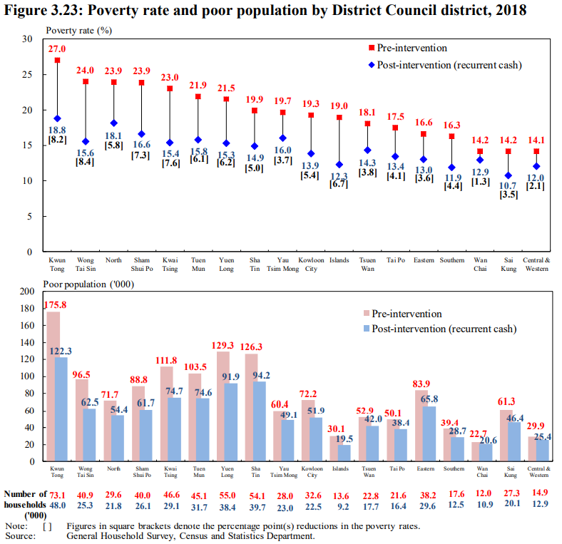
Figure 9: Poverty rate and poor population by districts, 2018
Note: Figures in square bracket […] refer to the percentage reduction of poverty rates.
Source: Census and Statistics Department, HKSAR Government

1.2.5 Poverty rate and poor population by selected socio-economic groups
Empirical studies found that two social groups suffered the most from inequality in Hong Kong are the elderly and single-parent families.

- Poor elderly
In 2018, the pre-intervention number of poor elders increased to 516,600, as shown in Figure 10. The poverty rate of the elders remained relatively stable at 44.4% in 2018. After the recurrent cash policy, poverty rate dropped to 30.9% in 2018. This reflected the poverty alleviation effect of the CSSA and Old Age Allowance (OAA) for the elders.
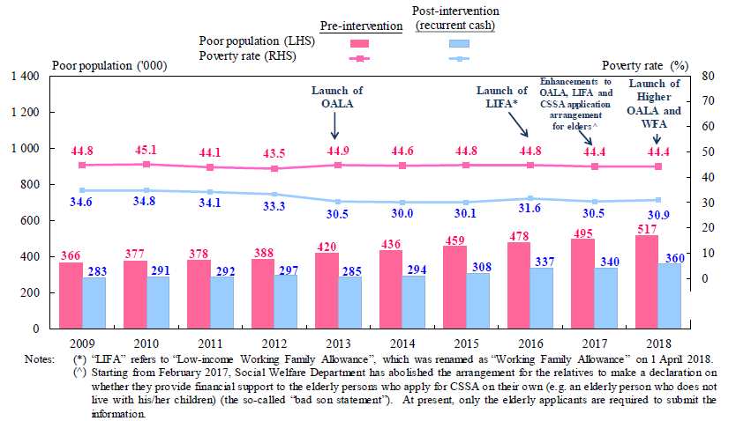
Figure 10: Poor population and poverty rate of the elderly, 2009-2018
Source: Census and Statistics Department, HKSAR Government

Over the period from 2013 to 2018, the post-intervention (recurrent cash (CSSA)) poor elders living in CSSA households were reduced from 20.1% (57,400 elders) to 10.8% (38,900 elders) as shown in Figures 11 and 12. [For the remaining poor elders living in non-CSSA households, the proportion of economically inactive poor elders was reduced from 96.8% in 2013 to 89.2% in 2018. Nevertheless, the economically inactive poor elders still remain as the dominant majority.]
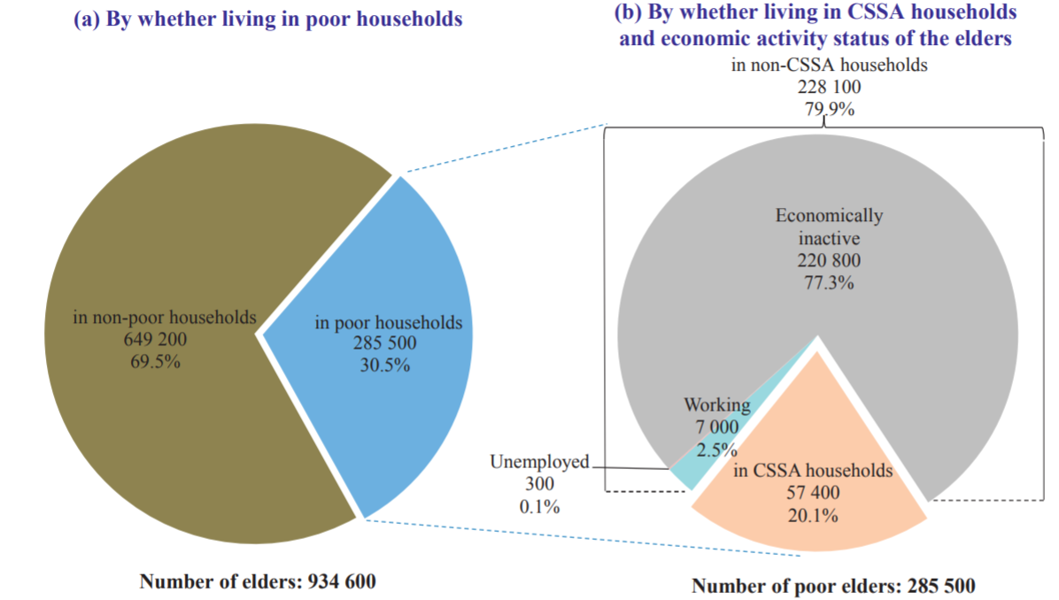
Figure 11: Poor elders by whether living in poor CSSA-receiving households and economically active status, 2013
Note: Based on the poverty statistics after recurrent cash intervention.
Source: Census and Statistics Department, HKSAR Government

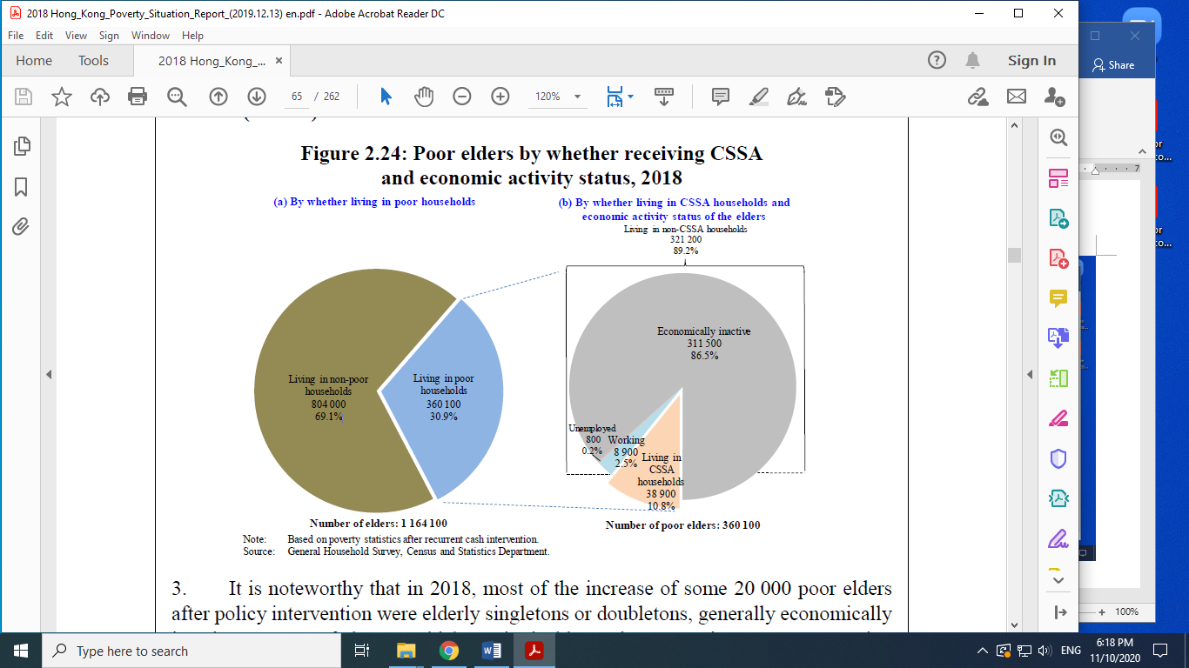
Figure 12: Poor elders by whether living in poor CSSA-receiving households and economically active status, 2018
Note: Based on poverty statistics after recurrent cash policies.
Source: Census and Statistics Department, HKSAR Government

For final remark, cautious interpretation of the poverty situation of the poor elderly is necessary as “income poor, asset rich” e.g. (“income-poor, owning property of certain value”) retired elders, who are living on their savings and superannuation (or pension) are classified wrongly as in the poverty statistics. This echoes the limitation of the poverty line framework by taking only the household income into account.

- Single-parent poor households
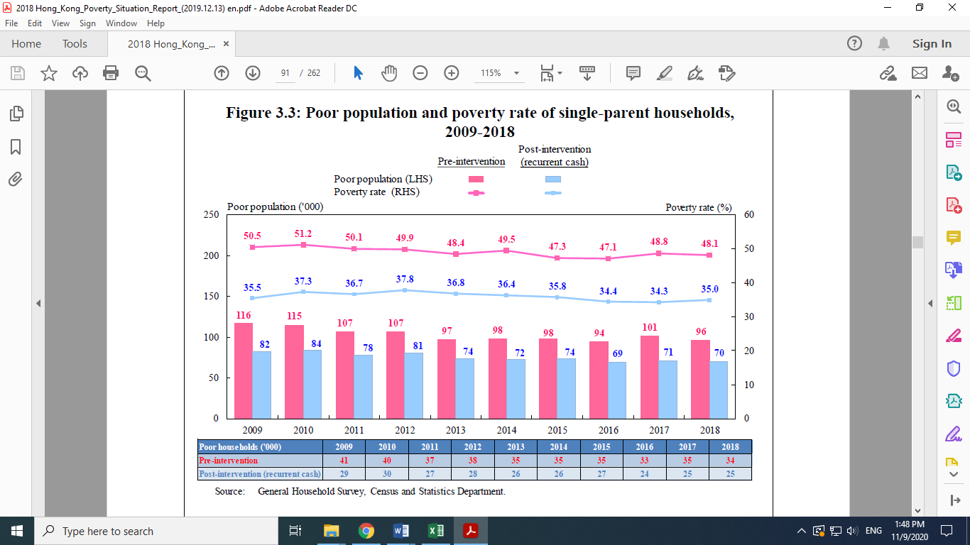
Figure 13: Poor population and poverty rate of single-parent households, 2009-2018
Source: Census and Statistics Department, HKSAR Government
For the period 2009 to 2018, the post-intervention number of single-parent poor households were largely decreasing but remained at a steadily high level. The underlying reason is that the single-parent poor households had a lower share of the working households (36.6%). Many of the employed in these households only undertook part-time work (40.9%), and their underemployment rate was also higher (4.0%). A large proportion of these single parents could not fully participate in the job market due to their child care responsibilities, which resulted in lower incomes. Therefore, more than six-tenths (62.5%) of the pre-intervention poor households had to apply for CSSA.
Compared with the overall poverty rates, the poverty rate of these single-parent households was higher because the majority had only one working member and carried a heavier family burden of raising 1.3 children on average, which was substantially higher than that of the overall households (0.4 children). Comparing the pre-and post-intervention poverty statistics, 9,300 households (26,200 persons) were lifted out of poverty, with the poverty rate reduced by 13.1%. Note that the policy outcomes in 2017 are better than those of 2018.

Part II: Sources of income inequality and poverty
- Different level of human capital (innate ability, education and training)

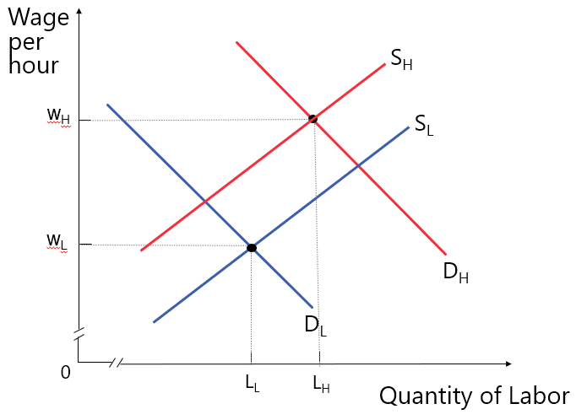
Figure 14: Wages levels between high-skilled and low-skilled labours
For example, when high-skilled labours have a relatively higher demand (D_{H}) and lower supply (S_{H}) than the low-skilled labours, there will be a higher equilibrium wage rate for labours with greater human capital.

- Hiring and promotion discriminations in age, gender, race, religion, and the effect on hiring and wage rate

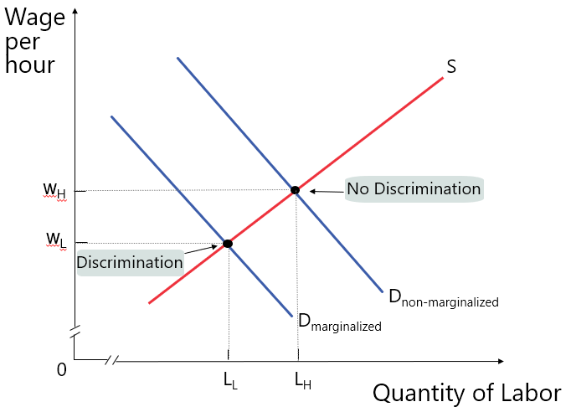
Figure 15: Wages levels with and without discrimination
Labour demand for the discriminated labour is lower than that of the non-discriminated, resulting in a lower equilibrium wage rate for the discriminated, despite the discriminated labour the same or even higher level of productivity.
On the labour supply side, if the discriminated are marginalized to certain restricted occupations (e.g. poor female aged 60-65 can mainly work as cleaners), this occupational crowding effect causes an oversupply of workers relative to demand in these occupations, resulting in lower wages and incomes. On the contrary, if women and minorities are restricted from entering into male-dominated occupations, there would also be an undersupply of workers, with similar results in wages and incomes. Furthermore, employers may fail to hire the job applicants by judging based on the return from hiring. For example, if a female of childbearing age becomes pregnant, then the salary payments in relation to time off for maternity leave during pregnancy and afterbirth might result in lower return on hiring the female worker for the firm. As a result, the firm may be just willing to offer a lower wage rate to female employees.

- Occupation and region
Industry | Median hourly wage (HK$) | Median monthly wage (HK$)
Manufacturing | 72.6 | 17,800
Electricity and gas supply; sewerage, waste management and remediation activities | 111.1 | 28,200
Construction | 99.9 | 23,500
Import and export trade | 80.3 | 18,800
Wholesale | 65.2 | 15,100
Retail trade | 53.8 | 14,000
Land transport | 79.6 | 19,800
Other transportation, storage, postal and courier services | 69.1 | 19,000
Food and beverage services | 52.2 | 13,800
Accommodation services | 58.1 | 16,200
Information and communications | 93.8 | 23,700
Financing and insurance | 111.0 | 28,300
Real estate activities | 90.0 | 23,000
Estate management, security and cleaning services | 45.9 | 13,000
Professional, scientific and technical activities | 95.8 | 24,300
Administrative and support services activities | 71.0 | 17,000
Travel agency, reservation service and related activities | 66.5 | 15,300
Education and public administration (excluding the government) | 131.8 | 29,200
Human health activities; and beauty and body prettifying treatment | 89.6 | 19,500
Miscellaneous activities | 51.6 | 13,100
Other activities | 67.9 | 16,300
Table 5: Median wages in selected industries in Hong Kong in 2019
Source: Report on Annual Earnings and Hours Survey, Census and Statistics Department of HKSAR Government

Industry | Median hourly earnings excluding overtime (£) | Median gross weekly earnings (£)
Agriculture, forestry and fishing | 10.21 | 479.1
Mining and quarrying | 18.16 | 769.4
Manufacturing | 14.22 | 593.1
Electricity, gas, steam and air conditioning supply | 19.84 | 766.6
Water supply; sewerage, waste management and remediation activities | 14.94 | 634
Construction | 15 | 650.1
Wholesale and retail trade; repair of motor vehicles and motorcycles | 11.97 | 489.4
Transportation and storage | 13.81 | 600
Accommodation and food service activities | 9.75 | 408.4
Information and Communication | 19.9 | 765.9
Financial and insurance activities | 21.89 | 785.8
Real estate activities | 14.58 | 554.1
Professional, scientific and technical activities | 18.47 | 704.2
Administrative and support service activities | 11.82 | 492.3
Public administration and defence; compulsory social security | 16.8 | 640.5
Education | 17.85 | 630.1
Human health and social work activities | 14.32 | 552.3
Arts, entertainment and recreation | 12.36 | 488.6
Other service activities | 13.06 | 501
Table 6: Median wages in selected industries in United Kingdom in 2019
Source: Annual Survey of Hours and Earnings of selected estimates, Office of National Statistics, Government of the United Kingdom

Work Region | Median hourly earnings excluding overtime (£) | Median gross weekly earnings (£)
North East | 13.55 | 533.2
North West | 13.86 | 550.5
Yorkshire and The Humber | 13.42 | 538.9
East Midlands | 13.27 | 535.3
West Midlands | 13.78 | 552.5
East | 14.42 | 581
London | 19.34 | 737.6
South East | 15.61 | 614
South West | 13.8 | 551.7
Table 7: Median wages by work regions in England in 2019
Source: Annual Survey of Hours and Earnings of selected estimates, Office of National Statistics, Government of the United Kingdom

The variation of income can be explained by the industry and geographical differences. As shown in Table 5, income inequality between industries can be observed in the education and financial industries which have the highest median earnings, whereas the catering industry, estate management and cleaning services industries have much lower average earnings in Hong Kong. On the other hand, in comparison with some less developed areas in England such as the North East and East Midlands, workers in London have higher median earnings as shown in Table 7. Since the Gini coefficient does not tell the source of inequality, hence it is necessary to take into account the demographic variations by region when determining a whole set of socio-economic indicators.

- Capital ownership and property income
In economics, various sources of income include rent, wages, financial returns and dividends. Aside from wages, the possession with or without housing assets and other financial assets will cause wealth inequality. Uneven wealth distribution among differing socioeconomic position will reinforce income inequality as a vicious cycle. When considering the process of wealth accumulation, the fundamental issue is the propensity to save. High-income households typically have a higher propensity to save (a lower propensity to consume). A life-cycle of earning, saving, and wealth-building pattern begins when a young person enters into the labour market and reaches its climax in his/her sixties (retirement age) and forms a wealth generation mechanism. Additionally, the intergenerational transfer also channels wealth into this mechanism. Households who inherit wealth are more likely to transfer that wealth to the next generation. Furthermore, a socio-economic marriage practice of the wealthy seeking wealthy partners, causing wealth concentration in a small number of families.

- Tastes and risk preferences
Entrepreneurs are willing to take risks, and they develop a stronger motive and capacity to engage in business ventures. Thus they are more likely to earn and save more income in the wealth accumulation process.

- Market structures of both product market and labour market
Market power in a product market enables a firm to earn monopoly profits by charging higher product prices. Equally, market power in the labour market allows a monopsony employer to earn monopsony profits by paying lower wages.

- Technological advancement
The global trend of technological advancement such as automation will cause divergent influence to the markets of low- and high-skilled workers in varying degrees. For high-skilled workers, they are easier to adapt to new technology-based working mode. Moreover, a process of capital deepening for saving costs increases the demand for high-skilled workers in technology-based industries. However, low-skilled labour may take time to master new technologies or even be replaced by machines (e.g. automation). This situation will lead to higher demand for high-skilled workers and lower demand for low-skilled workers. As a result, high-skilled workers will receive higher income, whilst earnings of the low and middle-skilled workers remain stagnant or even reduced. With the aid of technological advancement, the positive relationship between earnings and skill level of the labour will worsen income inequality.

- Change of economic condition (e.g. pandemic of COVID-19)
Usually, an economy suffers from lower product demand and high unemployment during recession. In 2020, the COVID-19 pandemic caused a significant negative impact on the global supply chains and disrupted many industries around the world. Economic recession in terms of the shrinking of both product and labour markets is the result of a negative unemployment chain as shown in Figure 16. On one hand, the deteriorating business environment forces employers to adjust payroll by reducing hours, wages, to granting paid or unpaid leave to workers. The worst scenario is layoff of staff, usually the middle- and low-skilled workers. Then, it is more difficult for them to find another job with similar wages and job rotation will cause productivity loss to new employers. Furthermore, additional costs of purchasing surgerical masks and other personal hygiene products create additional financial burdens to low-income households. Compared with low-income households, the adverse impacts of the pandemic will be less severe for high-income households. Thus, the pandemic of COVID-19 brings much more negative impacts to the disadvantaged and thus worsen poverty and inequality.
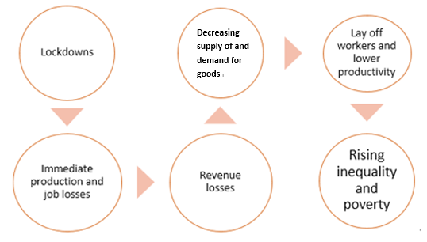

Figure 16: Negative unemployment chain
Furthermore, the pandemic of COVID-19 leads to different outcomes between developed and developing countries. In developed countries, four most affected industries are Airlines, Leisure Facilities (tourism-related), Oil and Gas Drilling and Auto Parts and Equipment, whilst the demand of ICT products, food delivery services and medical-related industries such as hospital services and personal hygiene products surge drastically.A recent study about the lockdown effect in Europe reveals that Gini coefficients rise by 2.2% in all selected countries. However, developing countries may suffer from resources constraints including cash flows, diagnostic services and medical facilities. Also, widespread informality in developing countries further intensifies the pandemic’s adverse consequences. Participants in the informal sector without formal business registration have no access to government benefits. Informality is associate with poverty, lack of access to financial systems, deficient public health and medical resources, and weak social safety nets etc. These issues magnified adverse impacts of COVID-19 and threatened to throw large numbers of people into extreme poverty. According to Poverty and Shared Prosperity Report 2020, the pandemic of COVID-19 is likely to push 88 million people into extreme poverty (living under US$1.90 a day) in 2020 and global extreme poverty rate would rise from 8.23% in 2019 to 8.82%, representing the first increase in global extreme poverty since 1998.

- Globalization
By shifting low-skilled jobs from developed countries to developing countries, the integration into global economy may increase income inequality within countries. Multinational firms, global outsourcing and global supply chain management are the underlying market drivers of the rise of low-cost foreign labours. Thus, declining demand of low-skilled labours in developed countries would decrease the wage in their local labour markets and may widen within-country inequalities of developed countries. Migration and the importation of foreign workers may increase the mobilities of both high-skilled labours and low-skilled labours, and hence may create more complexities in national income inequality.

- Luck or misfortune
Winning a lottery to gain a windfall income is good luck to an individual. In contrast, bankruptcy, prolonged illness, fatal accident, or natural disaster would cause a loss in income over a period of time and they are misfortunes for an individual.
Part III: Measures of mitigating income inequality and poverty
3.1 Measures
- Minimum wage
Excess supply of workers with low levels of homogeneous skill and experience in a very competitive labour market might give rise to an equilibrium wage level that is not sufficient for sustaining the costs of living. The government can regulate the labour market by setting a minimum wage above the equilibrium wage level as shown in Figure 17(a) in order to strengthen the bargaining power of these low skill workers. However, this policy induces the undesirable effect of higher unemployment among these low skill workers. Although workers who remain employed benefit from a higher wage level, those workers who are forced to be laid off due to the higher wage level (minimum wage) are worse off.

The magnitude of the effects of minimum wage on the labour market depends on the elasticity of demand for labour. As shown in Figure 17(b), comparing with the skilled workers, if the demand for unskilled workers is more elastic (flatter labour demand curve), especially in the long run when firms can adjust the level of employment fully, the effect of unemployment among the unskilled workers is relatively larger than that of the skilled workers (less elastic demand curve).

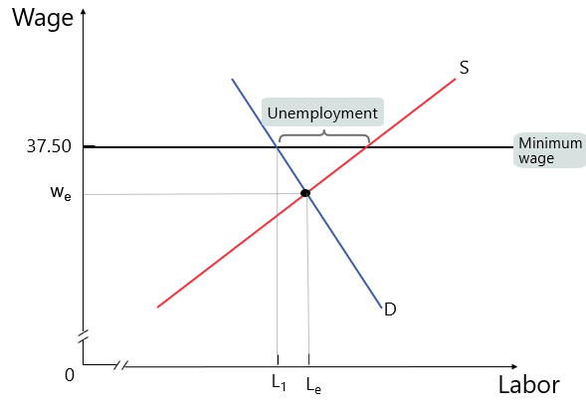  (a) | 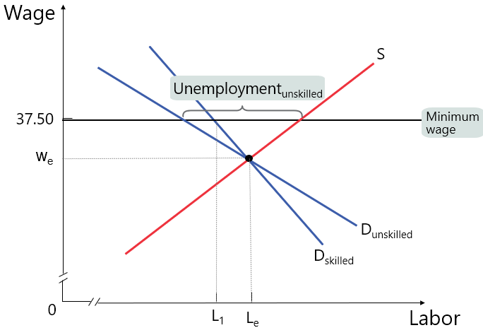  (b)
Figure 17: Effects of the minimum wage for (a) general case and (b) different elasticities of labour demand

- Rent control
When the market rent level is too high for most of the people to afford, the government may regulate the rental market by setting a maximum rent below the equilibrium rent level, as shown in Figure 18. Although the maximum rent imposes a price ceiling, i.e. lower rental costs, for the tenants, it generates a shortage of housing units for rental. Figure 18 shows that the number of rented housing units drops from 2.0 to 1.8 millions after imposing the maximum rent at $10,000 (down from $15,000). More tenants would find it difficult to rent housing units, i.e. allocation to consumers becomes inefficient, accompanied by wasted housing-related resources, and supply of low-quality housing units.
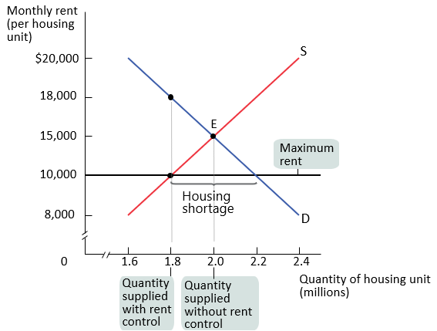
Figure 18: Rent control and housing shortage
- Progressive income tax
Progressive income tax purports to tax income at an increasing rate as taxable income increases. Under a progressive tax system, high-income households need to pay a higher proportion of their income as tax, the gap of income inequality can then be narrowed. However, the progressive tax reduces the incentive for people to gain better-paid jobs. Laffer curve analysis finds that when the marginal income tax rate reaches too high a level, it discourages people to work, and hurts economic growth. Therefore, progressive income tax may not be an appropriate scheme for achieving both economic growth and inequality reduction.

- Negative income tax
Negative income tax systematically collects tax revenue from high-income households who are earning above a certain income level. For the low-income households who earn below that income level would receive money from the govenment. This concept of tax was first proposed by Milton Friedman in 1962, with the claimed advantages of alleviating poverty, narrowing the income gap, and streamlining the social welfare system.

- Social Security programs
Monthly cash stipends are paid to the retired, disabled workers, and their surviving spouses and children through the old age pensions, disability allowances, and health benefits.

- In-kind transfer programs
Unlike a cash payment, people living below the poverty line and low-income households can collect short-term subsidized or even free food and services assistance, and other in-kind transfer programs, e.g. health care from the relevant government authorities or non-governmental organizations.

- Subsidized services
Government authorities can provide services at prices below the cost of production to assist the needy who cannot afford the services. The positive effects of these job training and education, health improvement services enhance labour productivity, social mobility, and thus reduce inequality and poverty.

Under the trend of technological advancement, raising the access to education of citizens across socio-economic positions directly improves their employment opportunities and enhances their earning power. Multiple forms of education ranging from adult education to vocational schools can help offer specific sets of employability skills. As the largest vocational training institute in Hong Kong, the Vocational Training Council (VTC) provides a breadth of programmes to learners of all ages. Also, the unemployed can take free courses from the Employee Retraining Board (ERB).

To deal with the pandemic, allocating more financial resources to the public health sector is crucial, for instance, enhancement in public health services with medical supplies and vaccines, which mitigates the negative impacts of the pandemic to the labour workforce and the subsequent rise of inequality and poverty.

- Social support programs
The Social Welfare Department of the HKSAR Government manages several portfolios of social support programs, including the Comprehensive Social Security Assistance Scheme, the Support for Self-reliance Scheme, the Portable Comprehensive Social Security Assistance Scheme, the Social Security Allowance Scheme, the Criminal and Law Enforcement Injuries Compensation Scheme, the Traffic Accident Victims Assistance Scheme, and so on.

Under the pandemic, direct cash assistance and unemployment assistance are immediate solutions for relieving high operating costs of the employers and daily needs of the unemployed respectively. In Hong Kong, firms may apply for “Employment Support Scheme” (ESS) under the “Anti-epidemic Fund” to provide time-limited financial support to retain employees. It may mitigate the negative impacts of the pandemic to the employers and the subsequent rise of inequality and poverty.

- Family-friendly policy
To facilitate the return of low-income households to the labour market, it is important to increase the quota for occasional child-care services and extend service hours.

- Alleviation of discrimination
Reduction of discriminative practices can take three forms of measures. As a preventive approach, education is crucial to develop inclusive awareness and create an inclusive environment. For increasing the incentives to prevent discriminative practises, government subsidies, legal enforcement and punishment can work in tandem.

3.2 Policy choice from the tradeoff
Redistributing income necessitates a tradeoff between equity and efficiency, known as the big tradeoff. The prime costs of redistributing income revolve around the income transfer from the rich to the poor. When a dollar is taken from a rich person, a poor person receives less than a dollar. The size of the economic pie shrinks through three mechanisms. Firstly, as an opportunity cost, productive resources are consumed to implement the income transfer programs rather than producing goods and services. Secondly, redistribution entails taxation of income, which imposes an efficiency loss to society. Thirdly, redistribution reduces the incentives for the taxpayers and the beneficiaries to provide productive works in the labour market.

3.3 Examples of policy measures for mitigating income inequality in Hong Kong
The poor | Social Welfare Department  Comprehensive Social Security Assistance (CSSA) Scheme  Working Family and Student Financial Assistance Agency (WFSFAA)  Kindergarten and Child Care Centre Fee Remission Scheme  School Textbook Assistance Scheme  Non-Means-Tested Loan Scheme for Full-time Tertiary Students (NLSFT)  Non-Means-Tested Loan Scheme for Post-secondary Students (NLSPS)
The unemployed | Social Welfare Department  Support for Self-reliance (SFS) scheme  Labour Department  Youth Employment and Training Programme (YETP)  Vocational Training Council (VTC) / Employees Retraining Board (ERB)  Training and Continuing Education
The disabled | Social Welfare Department  Pre-school Rehabilitation Services  Services for School Age Disabled Children  Services for Physically Handicapped Persons  Services for Mentally Handicapped Persons  Services for Ex-Mentally Ill Persons  Services for Visually Impaired Persons  Services for Hearing Impaired Persons  Vocational Rehabilitation Services  Employment/ Business Opportunities and Social Enterprise  Day Training Services  Residential Care Services  Community Support Services / Self-help Organizations of People with Disabilities / Chronic Illness  Labour Department  Work Orientation and Placement Scheme  Transport Department  Public Transport Fare Concession Scheme for the Elderly and Eligible Persons with Disabilities
Single parents | Social Welfare Department  Family Aide Service  Child Care Services  Family Life Education  Foster Care  Integrated Family Services  Residential Child Care Services
The elderly | Social Welfare Department  Old Age Living Allowance (OALA)  Portable Comprehensive Social Security Assistance (PCSSA) Scheme  Carer Support Service  Day Respite Service for Elderly Persons  Enhanced Home and Community Care Services (EHCCS)  Integrated Home Care Services (IHCS)  Homes for the Aged  Care and Attention Homes for the Elderly  Nursing Homes  Labour Department  Employment Programme for the Elderly and Middle-aged  Transport Department  Public Transport Fare Concession Scheme for the Elderly and Eligible Persons with Disabilities  Department of Health  Elderly Health Care Voucher Scheme

Part IV: International practices
4.1 Income Inequality
City | Gini coefficient
San Francisco | 0.521
Chicago | 0.531
Los Angeles | 0.531
Washington City, D.C. | 0.535
Hong Kong | 0.539 (2016)
New York City | 0.551
Country | Gini coefficient
Switzerland | 0.386
Korea | 0.396
Sweden | 0.432
Canada | 0.435
Austria | 0.494
Belgium | 0.5
Germany | 0.504
United States | 0.506
Finland | 0.507
France | 0.516
United Kingdom | 0.52
Italy | 0.524
Spain | 0.524
Ireland | 0.545
Table 8: Gini coefficient (Original household income) in selected places and Hong Kong in 2015
Source: Census and Statistics Department, HKSAR Government and OECD.

Table 8 offers a set of the Gini coefficients of both metropolitan cities and individual countries in 2015. Income inequality in a highly developed urban areas are generally greater than those economies driven by agricultural and manufacturing activities. Thus, it is more appropriate to compare income inequality in Hong Kong with that in other metropolitan cities. As the Gini coefficients in Table 8 reveal that Hong Kong’s income inequality based on original household income in 2015 (0.539) is comparable to those of the major metropolitan cities in the developed western countries, e.g. New York City (0.551), Washington, D.C. (0.535) and Los Angeles (0.531).

4.2 Poverty
Among the comparative international studies on global poverty, the standard absolute international poverty line (IPL) of USD 1.90 per person per day at purchasing power parity (PPP) is used by the World Bank, the United Nations, the Organisation for Economic Co-operation and Development (OECD), and the other international non-governmental organizations since 2015. It represents the international equivalent of what USD 1.90 could buy in the United States in 2011. Individuals are considered as poor if they live in a household with a daily per capita consumption or income of less than USD 1.90. However, it is far from the poverty line in Hong Kong and other developed countries due to much higher costs of living, compared with a poor country in Africa.
Table 9 shows the poverty measures established by various countries and international organizations. The European Commission adopts the relative poverty measure, while the United States approach is a modified absolutist approach, which represents the necessary purchasing power to meet a citizen’s basic needs. Though the UK does not establish an official poverty line, it defines poverty in terms of a combination of absolute income, relative income, material deprivation and low income, and persistent poverty to capture the multi-dimensional aspects of poverty (particularly the duration).
 | OECD | European Union | United States | United Kingdom | South Korea
Official poverty line | 50% of median household disposable income | 60% of median household disposable income | Three times the cost of minimum food diet in 1963 adjusted for inflation | Nil | Nil
Other measures | Nil | Nil | Nil | - 60% of median household disposable income (relative)  - household income less than 2010/11 income threshold with adjusted inflation (absolute)  - household income less than income threshold at least 3 of previous 4 years (persistent)  - combined low income and material deprivation | Minimum cost of living
Table 9: Poverty measures adopted by selected countries and international organizations
Source: Legislative Council, HKSAR Government

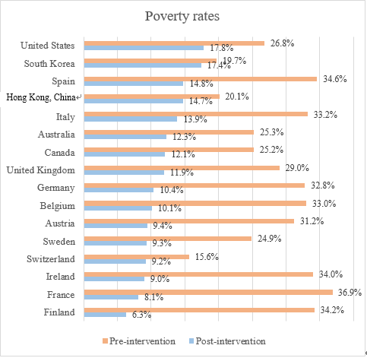
Figure 19: Poverty rates in selected OECD countries and Hong Kong in 2017
Figure 19 compares the pre-and post-intervention among some highly-developed countries. Hong Kong is less suffered from poverty according to the pre-intervention rate of 20.1% (only higher than the lowest poverty rates of 15.6% in Switzerland and 19.7% in South Korea). However, the post-intervention poverty rate ranks higher approaching the top three countries, due to lower social welfare expenditure in Hong Kong. Note that poverty is a pressing problem not only in developing countries but also in developed countries/regions with approximately one-fourth to one-third of the population among the OECD countries and regions are in poverty.

Part V: Suggested questions for further enquiries
Source A: Measuring poverty in Hong Kong
Prior to 2013, the Government of Hong Kong did not officially define a poverty line. Instead, the Comprehensive Social Security Assistance (CSSA) level has practically been used as the de facto “poverty line” since 1971. The standard rates, supplements, and special grants of the CSSA scheme are computed on the basis of an individual’s “basic needs budget” accordingly. Hence, the “absolute poverty” concept has been adopted by the Hong Kong Government to define poverty.

In Sept 2013, the Commission of Poverty (CoP) of the HKSAR Government established the first “poverty line”. Its objectives are: (a) to identify the population of the poor for understanding the overall poverty situation; (b) as input for the formulation and implementation of various government policies and measures; and (c) to evaluate policy effectiveness of poverty alleviation. After several rounds of discussions, the CoP finally agreed that the poverty line should be based on the concept of “relative poverty” and set at 50% of the median monthly household income before policy intervention(pre-tax and social transfer). Conceptually, people are living in “relative poverty” when they cannot enjoy a customary lifestyle with socially determined essential needs in the society.

Poverty line however does not take assets and liabilities into account. Since the poverty line takes household income as the sole indicator for measuring poverty, some “asset-rich, income-poor” persons may be classified as poor. Particularly, some retired elders possess considerable amount of savings, stocks or holding properties, and their actual living standards might be under-estimated.

In addition, under normal circumstances, there are always people in poverty statistically based on a “relative poverty” line set at a percentage of the pre-intervention median household income. Therefore, an economic upturn does not reduce the size of the poor population.

Every year, Census and Statistics Department compiles “Hong Kong Poverty Situation Report”, which includes annual updates of poverty line and the detailed analysis of poverty situation of both overall trend and various selected household groups in terms of demographic characteristics.

Source:
Commission of Poverty, HKSAR Government;
Fong, Florence Meng-soi and Wong, Chack-kie (2017) Setting the Poverty Line: Policy Implications for Squaring the Welfare Circle in Hong Kong. In Lau, Maggie K. W. and Gordon, David (eds) Poverty in a Rich Society: The Case of Hong Kong. Hong Kong: The Chinese University Press. pp. 84;
Hong Kong Poverty Situation Report 2018, Census and Statistics Department of HKSAR Government;
Townsend (1979) Poverty in the United Kingdom: A Survey of Household Resources and Standards of Living. England: Penguin, pp. 31.

- Refer to Source A, what are the functions of the poverty line in Hong Kong? (3 marks)

Ans:
- identify population of the poor for understanding the overall poverty situation;
- provide useful information for the formulating and implementing various government policies and measures, and
- evaluate policy effectiveness of poverty alleviation. (3 marks)

- Refer to Source A, what are the limitations of the poverty line? (4 marks)

Ans
(1) Assets and liabilities are not considered. It could not fully reflect the living conditions of some “asset-rich, income-poor” (or “high-debt, high-income”) persons (2 marks)
(2) Under normal circumstances, there are always people in poverty statistically based on a “relative poverty” line set at a percentage of the pre-intervention median household income. Therefore, an economic upturn does not reduce in the size of the poor population. (2 marks)

- Refer to Source A, and apply relevant knowledge in economics, explain whether the poverty line can accurately measure the poverty problem in Hong Kong. (6 marks)

Ans
Partially. As the poverty line does not take assets and liabilities into account, some retired elders possess considerable amount of savings, stocks or holding properties, and their actual living standards might be under-estimated. Except this, the income-based poverty line is a fairly useful measure for identifying most of the poor population according to the designated threshold of living standard with essential social needs. When the poverty line can identify the poor in various social groups who cannot enjoy a certain level of living standard, it can thus help formulate different kinds of government policies to match with specific needs. (6 marks)

Source B: Education, Technology and Inequality
An economist argues that globalization and the advent of new technologies are the two main causes of income inequality. However, globalization and technological advance are also the main forces driving rapid economic growth. Therefore, inhibiting development of these two phenomena will do far more harm than good in the next century.

He also suggests that the best method to improve economic opportunities is to raise the level of and access to education. Education is comprised of many forms: early childhood education, adult education, community colleges, on-the-job training, vocational schools and various online courses. With better skills, lifetime earning power would rise as a result.

With the advances in ICT and global supply chain management, globalization drives rapid development of more labour saving (e.g. automation) and skill intensive technologies. With the rise of superstar managers and growing demand for highly skilled workers who earn extraordinary higher wages, whilst earnings of the low and middle-skilled workers remain stagnant or even reduced, wage and income inequalities widen as a result.

Source: International Herald Tribune (2008) Bernanke Links Education and Equality; Rotman, David (21/10/2014). Technology and inequality. MIT Technology Review.

- According to the economist in Source B, what are the merits and demerits of globalization and technological advancement, and how does increased education narrow the gap of economic inequality? (6 marks)
Ans:
Globalization and technological advancement are the two main causes of deteriorating income inequality and drive rapid economic growth. (2 marks)

Increased education directly related to the highly demanded skills would lift employability of average individual, which boost the likelihood to land a higher-income job and mitigate the problem of inequality. (4 marks)

Source C: Income shares in the United States in 2001 and 2018.
Households (Quintile) | 2001 Income  (share of total) (%) | 2018 Income  (share of total) (%)
Lowest | 3.5 | 3.1
Second | 8.8 | 8.3
Third | 14.5 | 14.1
Fourth | 23.1 | 22.6
Highest | 50.1 | 52.0
Source: Statista: Shares of household income of quintiles in the United States from 1970 to 2019
- Refer to Source C, describe the inequality situation of the U.S. in 2018. Evaluate whether the income distribution in the U.S. was more equal in 2001 than in 2018? (4 marks)

Ans:
From 2001 to 2018, income inequality in the United States increased over that period. The top quintile increases its share of income. However, both the middle quintile and the lowest quintile have a lower share of income. (4 marks)

Source D: Potential change of fiscal policy to mitigate inequality
Recently, an economist wrote in a financial magazine claiming that Asia needs higher taxes to help its poor to prosper. More than 80 percent of Asians live in countries where inequality is widening. Fiscal policy can play an important role to achieve this policy goal. Governments should invest more on improving access to education and health care. Furthermore, governments should adjust their tax policies to raise more revenue to fund increases in public spending.

One option is to increase salaries tax. Another option is to introduce sales or corrective tax. Taxes on salaries, property, capital gains and inheritance can be structured to be progressive, claiming a higher portion of income from the rich to be transferred to the poor.

Hong Kong has one of the lowest income tax rates in the world that returns a higher share of profits and income to the business sector and high-income group. However, the income inequality has been widened as a result where the middle- and low-income groups are the most affected adversely by rising housing prices and rental costs.

Source: South China Morning Post (27/08/2014) Hong Kong should reform its tax structure to redistribute wealth
Adapted from: https://www.scmp.com/comment/article/1581091/hong-kong-should-reform-its-tax-structure-redistribute-wealth

- Refer to Source D, what government policies can potentially be implemented to reduce economic inequality? (3 marks)

Ans:
Increase the progressivity of salaries tax, and increase the transfer payment by spending more on public education and health care. (3 marks) (give marks to other acceptable answers, with 3 as the maximum marks)

- Suppose the government takes either of the following tax policies to provide the benefits for the low-income groups. Refer to Source D, and apply relevant knowledge in economics, compare how each of these two tax policies would affect income inequality in Hong Kong.
- Increases the progressivity of salaries tax (2 marks)
- Introduce a sales tax (4 marks)

Ans:
Due to the progressivity of the salaries tax, a higher tax burden falls onto the high-income households as the salaries tax accelerates at a rate larger than that of the low-income households. Since the increase of the resulting tax revenue would be transferred to fund social benefits, this tax policy measure would be able to mitigate income inequality. (2 marks)

For the introduction of a sales tax, low-income households pay a relatively larger proportion of their income than high-income households. But social benefits may help meet the daily needs of low-income households, the effects on income inequality is uncertain as it depends on which magnitude is larger. (4 marks)

Source E: Economics of Low-Price product
Affected by the COVID-19 epidemic, the increasing unemployment causes the income level of individuals and even families to drop substantially. As a consequence, the consumption of inferior goods increases due to lockdown. Typical examples are cup noodles, hamburgers in fast-food chains, etc.

With the spread of online business models, fast food chains also make good use of mobile App to launch e-coupon as advertisement and promotion strategy. Customers can enjoy special offers every week. Some products are even offered for big discounts to drive cross-selling.
Source: iMoney網上專欄 (27/08/2020) 商業冰河中逆襲 價廉物美經濟學
Adapted from: https://bit.ly/3cdfmgH
- Refer to Source E, discuss how deteriorating income towards the poverty threshold influences the consumption of two kinds of goods (normal goods and inferior goods) for the poor using demand-supply diagrams respectively. (4 marks)

Ans:
Refer to the figures below, as the income level is reduced towards the poverty threshold, further reduction in disposable income would reduce the demand of a normal good, but increase the demand of an inferior good. (4 marks with correct graphs)
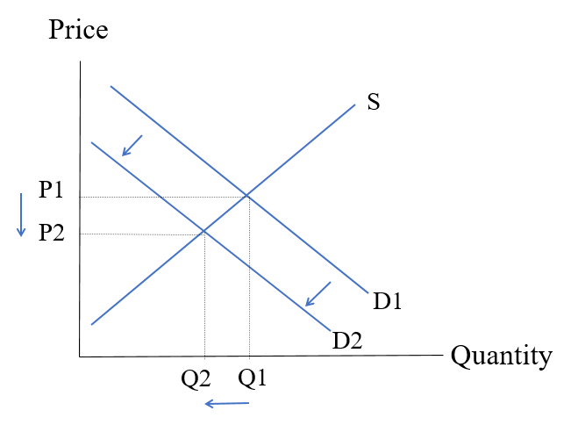 | 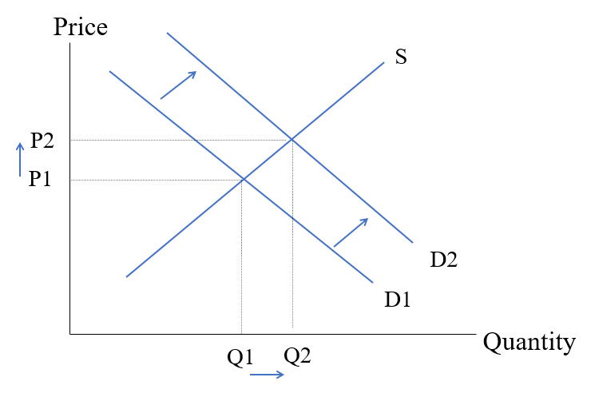
Normal Good | Inferior Good

- To alleviate the problem of income inequality, some politicians raised the following proposals:
  - Proposal 1: Lower the age threshold from 65 to 60 for $2 elderly public transport fare concession scheme
  - Proposal 2: Implement work-incentive-based transport subsidy scheme
  - Proposal 3: Increase government funding to vocational training institutes
Evaluate the above proposals in terms of aggregate output and equality. (12 marks)
Ans:
In terms of output level, Proposal 1 “Enhance the transport fare concession” can target the elderly by specifying the usage and provide incentives to return to the workplace. Low-income elderly can travel farther away from their residential area and increases their opportunities with higher-income jobs. Thus, it improves income inequality and boosts aggregate output.

In terms of output level, Proposal 2 “Implement work-incentive-based transport subsidy scheme” can target the needy by specifying the usage and provide incentives to return to the workplace. Thus, it improves income inequality and boosts aggregate output. Also, from the perspective of equality, it improves equality by equalizing opportunity as all potential low-income individals can travel farther away from their residential area and increases their opportunities with higher-income jobs.

In terms of output level, Proposal 3 “Increase government funding to vocational training institutes” can boost productivity on some labours and thus disposable income. In addition to raising government expenditure, it further boosts aggregate output. From the perspective of equality, Proposal 3 can improve equality by equalizing opportunity that more people can join the labour force or earn a higher salary after receiving the training.

Source F: Selected policies of HKSAR Government for mitigating income inequality
Target group | Selected policy
The poor | Social Welfare Department  Comprehensive Social Security Assistance (CSSA) Scheme
The unemployed | Labour Department  Youth Employment and Training Programme (YETP)  Employment Programme for the Elderly and Middle-aged
Single parents | Social Welfare Department  Family Aide Service  Day Child Care Services
The elderly | Social Welfare Department  Old Age Living Allowance (OALA)  Portable Comprehensive Social Security Assistance (PCSSA) Scheme  Department of Health  Elderly Health Care Voucher Scheme
Source: HKSAR Government
- Search the information of the policies in Source F and suggest any two measures that can help alleviate the problem of income inequality. (8 marks)
Ans: (Any two below)
- Develop vocational training programmes (2 marks): Increase industry-specific skills and productivity for low-skilled labours.
- Enhance transparency of job market (2 marks): Organize more career fairs for low-skilled labours (2 marks)
- Enhance career support for the poor families’ teenagers (2 marks): Help teenagers from low income families to get access to more opportunities to further education in order to be well-equipped for joining occupations with better pay or prospects. Reduce intergenerational poverty (2 marks)
- Promote online business with flexible work arrangements e.g. working from home and flexible working time (2 marks): Increase positions for the poor, especially single parent and the poor individual cannot get full-time jobs (2 marks)
- Any other relevant points with explanation (4 marks)

Suggested teaching activitities (tasks to do in group):
Source G: Selected policies of HKSAR Government for mitigating inequality
Target group | Selected policy
The poor | Social Welfare Department  Comprehensive Social Security Assistance (CSSA) Scheme  https://www.swd.gov.hk/en/index/site_pubsvc/page_socsecu/sub_comprehens/
The unemployed | Labour Department  Youth Employment and Training Programme (YETP)  https://www.yes.labour.gov.hk/Home  Labour Department  Employment Programme for the Elderly and the Middle-aged  https://www1.jobs.gov.hk/0/en/information/Epem
Single parents | Social Welfare Department  Family Aide Service  https://www.swd.gov.hk/en/index/site_pubsvc/page_family/sub_listofserv/id_familyaide/  Day Child Care Services  https://www.swd.gov.hk/en/index/site_pubsvc/page_family/sub_listofserv/id_childcares/
The elderly | Social Welfare Department  Old Age Living Allowance (OALA)  https://www.swd.gov.hk/oala/index_e.html  Portable Comprehensive Social Security Assistance (PCSSA) Scheme  https://www.swd.gov.hk/en/index/site_pubsvc/page_socsecu/sub_portableco/  Department of Health  Elderly Health Care Voucher Scheme  https://www.hcv.gov.hk/eng/index.htm
  - Search the information of the policies in Source G,
  - Check the website of the scheme to find the details of the scheme e.g. objectives, eligibility
  - Discuss what problems do the targeted people face e.g. the poor find food expense is unaffordable.
  - Discuss how the scheme can help them with respect to equality, unemployment and other macroeconomic goals.
Useful Materials for the Topic
HKSAR Government – Census and Statistics Department | https://www.censtatd.gov.hk/home/
HKSAR Government – Social Welfare Department | https://www.swd.gov.hk/en/index/
HKSAR Government – Labour and Welfare Bureau | https://www.lwb.gov.hk/en/index.html
HKSAR Government – Labour Department | https://www.labour.gov.hk/front.htm
HKSAR Government – Department of Health | https://www.dh.gov.hk/eindex.html
HKSAR Government – Work Family and Student Financial Assistance Agency | https://www.wfsfaa.gov.hk/en/index.htm
HKSAR Government – Transport Department | https://www.td.gov.hk/tc/home/index.html
HKSAR Government – Community Care Fund | https://www.communitycarefund.hk/en/index.php
HKSAR Government – Commission of Poverty | https://www.povertyrelief.gov.hk/
Vocational Training Council (VTC) | https://www.vtc.edu.hk/html/tc/
Employees Retraining Board (ERB) | https://www.erb.org/home/erb/en/
International Labour Organization (ILO) | https://www.ilo.org/global/topics/poverty/lang--en/index.htm
The Organisation for Economic Co-operation and Development (OECD) | https://www.oecd-ilibrary.org/sites/8483c82f-en/index.html?itemId=/content/component/8483c82f-en
The Oxfam | https://www.oxfam.org.hk/en/what-we-do/development-programmes/hong-kong
The World Bank | https://www.worldbank.org/en/understanding-poverty
U.S. Bureau of Economic Analysis | www.bea.gov

Further Reading
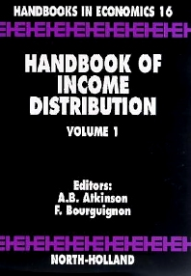 | - Title: Handbook of Income Distribution (Vol 1-2)  - Author: Anthony B. Atkinson and François Bourguignon
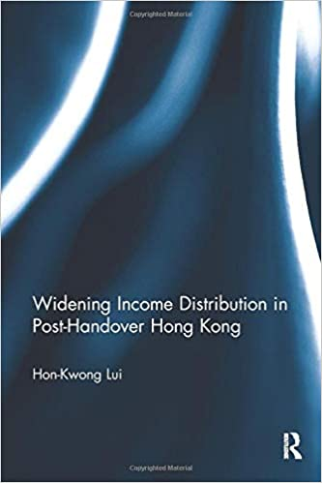 | - Title: Widening Income Distribution in Post-Handover Hong Kong  - Author：Hon-Kwong LUI  - Link of Hong Kong public libraries:  https://webcat.hkpl.gov.hk/lib/item?id=chamo:3269533&fromLocationLink=false&theme=WEB
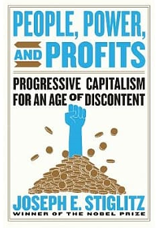 | - Title: People, Power, And Profits: Progressive Capitalism for an age of discontent  - Author: Joseph E. Stiglitz  - Link of Hong Kong public libraries:  https://webcat.hkpl.gov.hk/lib/item?id=chamo:3561481&fromLocationLink=false&theme=WEB
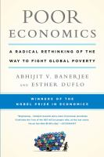 | - Title: Poor Economics: A Radical Rethinking of the Way to Fight Global Poverty  - Author: Abhijit V. Banerjee and Esther Duflo  - Link of Hong Kong public libraries:  https://webcat.hkpl.gov.hk/lib/item?id=chamo:3571017&fromLocationLink=false&theme=WEB

Sustainable Development Goals (SDGs) are a list of 17 interlinked global goals designed to be a "blueprint to achieve a better and more sustainable future for all". The SDGs were adopted by all United Nations Member States in 2015, known as the 2030 Agenda which set out a 15-year plan to achieve them. They are: (1) No Poverty, (2) Zero Hunger, (3) Good Health and Well-being, (4) Quality Education, (5) Gender Equality, (6) Clean Water and Sanitation, (7) Affordable and Clean Energy, (8) Decent Work and Economic Growth, (9) Industry, Innovation and Infrastructure, (10) Reducing Inequality, (11) Sustainable Cities and Communities, (12) Responsible Consumption and Production, (13) Climate Action, (14) Life Below Water, (15) Life On Land, (16) Peace, Justice, and Strong Institutions, (17) Partnerships for the Goals.
McKay, A (2002) Inequality Briefing: Defining and measuring inequality, Briefing Paper No. 1, March 2002, Economists’ Resource Centre, UK Department for International Development.
Alcock, P. (1997) Understanding Poverty, Second edition. London: Macmillan.
The United Nations Secretariat (2020) The World Social Report 2020: Inequality in a rapidly changing world, The Department of Economic and Social Affairs.
Naschold, F. (2002) Inequality Briefing: Why Inequality matters for poverty, Briefing Paper No. 2, March 2002, Economists’ Resource Centre, UK Department for International Development.
HKSAR Government (2017) Thematic Report: Household Income Distribution in Hong Kong, 2016 Population By-census, Census and Statistics Department of HKSAR Government. p.180-181.
Ibid., p.11.
https://www.hkeconomy.gov.hk/en/pdf/wp/gini_comparison.pdf
HKSAR Government (2017) Census and Statistics Department announces results of study on household income distribution in Hong Kong, Census and Statistics Department of HKSAR Government, 9 Jun.
HKSAR Government (2017) Thematic Report: Household Income Distribution in Hong Kong, 2016 Population By-census, Census and Statistics Department of HKSAR Government, p. 96.
https://www.investopedia.com/terms/g/gini-index.asp#:~:text=The%20Gini%20index%20is%20a,total%20income%20of%20the%20population.
Oxfam Hong Kong Inequality Report
2017 4th quarter Quarterly Report on General Household Survey
http://www.oecdbetterlifeindex.org/topics/housing/
Census and Statistics Department, Results of the 2014/15 Household Expenditure Survey, https://www.statistics.gov.hk/pub/B71608FB2016XXXXB0100.pdf
Census and Statistics Department, Thematic Report: Persons Living in Subdivided Units, https://www.bycensus2016.gov.hk/data/16BC_SDU_report.pdf
Census and Statistics Department, Thematic Household Survey Report No. 60: Housing conditions of sub-divided units in HK https://www.statistics.gov.hk/pub/B11302602016XXXXB0100.pdf
Townsend (1979) Poverty in the United Kingdom: A Survey of Household Resources and Standards of Living (England: Penguin). p. 31.
Bradshaw, J. and Ernst, J. (1990) Establishing a Modest but Adequate Budget for a British Family, York: University of York, Family Budget Unit.
Legislative Council (1998) The Measurement of Poverty, Research and Library Services Division, Legislative Council Secretariat
HKSAR Government (2019) Main Analysis of the Poverty Situation in 2018, Commission on Poverty Paper No. 6th/2019-20, 13 December, Census and Statistics Department of HKSAR Government.
Peng, C. H. and et al. (2019) Determinants of Poverty and Their Variation Across the Poverty Spectrum: Evidence from Hong Kong, a High-Income Society with a High Poverty Level, Social Indicators Research, 144, pp. 219–250.
Note that United Kingdom in Table 6 refers to an European country, while England in Table 7 refers to the largest region of the United Kingdom.
Rotman, D. (2014) Technology and inequality. MIT Technology Review, October 21.
ILO (2020) The World of Work and COVID-19. International Labour Organisation. June 2020.
Barrett, E. (2020) Hong Kong dangles incentives for local face mask production as coronavirus stretches supply. Fortune, March 18; Sun, F. (2020) Rising food prices during pandemic add to burdens of Hong Kong’s poor, with more seeking handouts, South China Morning Post, May 2.
Haydon, D. and Kumar, N. (2020) Industries Most and Least Impacted by COVID-19 from a Probability of Default Perspective – September 2020 Update, S&P Global Blog, Sept 21; Fuk, J. (2020). COVID-19 Lockdown boosted growth of digital platforms, S&P Global Blog, September 25.
Palomino, J. C., Rodríguez, J. G. and Sebastian, R. (2020) Wage inequality and poverty effects of lockdown and social distancing in Europe, in Covid Economics, The Centre for Economic Policy Research (CEPR), 25, pp. 186-229.
The World Bank (2020a) Global Economic Prospects Report, the World Bank, June 2020; The World Bank (2020b) Poverty and Shared Prosperity Report 2020, the World Bank, October 2020.
Note that our discussion of various plausible argments between globalization and inequality here may not empirically valid.
Mankiw, N. G. (2018) Principles of Microeconomics, 8th edition, Boston: Cengage, pp. 161-164.
For instance, if income floor was set at $30,000, and negative income tax rate was 40%, when someone who earned $15,000, he would receive $6,000. If someone earned $25,000, he would receive $2,000.
Oxfam Hong Kong Inequality Report
“Employment Support Scheme” in Hong Kong: https://www.ess.gov.hk/en/
Ibid., p.145. OECD Stat (2020) Income Distribution Database (Gini: market income, before taxes and transfers).
HKSAR Government (2017) Thematic Report: Household Income Distribution in Hong Kong, 2016 Population By-census, Census and Statistics Department of HKSAR Government, p.143-148.
Legislative Council (2013) Measurement of poverty (Information Note), Research Office, Legislative Council Secretariat.

